COST ACCOUNTING
Accounting serves the purpose of providing financial information relating to activities of a business. Such information is provided to shareholders, managers, creditors, debenture holders, bankers, tax authorities and others. Broadly speaking on the basis of type of accounting information and the purpose for which such information is used; accounting may be divided into three categories
- Financial Accounting
- Cost Accounting
- Management Accounting
Financial accounting is concerned with recording business transactions in the books of accounts for the purpose of presenting final accounts to management, shareholders and tax. It is defined as the art of recording classifying and summarizing in a significant manner and in terms of money transaction and events which are in part at least, of a financial character and interpreting the result thereof.
Management accounting: according to National Association of Accounts it is the process of identification, measurement, accumulation analysis preparation and communication of financial information used by management to plan evaluate and control within the organization and to assure appropriate use and accountability for its business.
Costing means the techniques and process of ascertaining costs.
Cost accounting means it is the process of accounting for costs from the point which expenditure is incurred or committed to the establishment of its ultimate relationship with cost centers and cost units.
Objectives of Cost Accounting:
- Ascertainment of cost: this is the primary objective of cost accounting. For cost ascertainment different techniques and systems of costing are used under different circumstances.
- Control of costs: it aims at improving efficiency by controlling and reducing cost.
- Guide to business policy: it aims at serving the needs of management in conducting the business with utmost efficiency.
- Determination of selling price: it provides cost estimation on the basis of which selling prices of products or services may be fixed.
- Measuring and improving performance: it measures efficiency by classifying and analyzing cost data and then suggests various steps in improving performance so that profitability creased.
Advantages of Costing:
- Reveals profitable and unprofitable activities
- Helps in cost control
- Helps in decision making
- Guides in fixing selling prices
- Helps in inventory control
- Aids in formulating policies
- Helps in cost reduction
- Reveals idle capacity
- Checks inaccuracy of financial accounts
- Prevents frauds and manipulation

FINANCIAL ACCOUNTING PREPARING PROFIT AND LOSS ACCOUNT AND BALANCE SHEETS
COST ACCOUNTING ANALYSING COST FOR CONTROL AND MAXIMISING EFFICIENCY
MANAGEMENT ACCOUNTING ASSISTING MANAGEMENT FOR PLANNING, DECISION MAKING AND CONTROL

Concept of Cost: cost is the amount of expenditure incurred or attributable to a given thing
Expense: it an expired cost resulting from a productive usage of an asset.
Loss: reduction in firm’s equity other than from withdrawals of capital for which compensating value has been received.
Methods of costing:
- Job order costing
- Contract or terminal costing
- Batch costing
- Process costing
- Operating costing
- Single or unit costing
- Service costing
- Multiple or composite costing
Techniques of costing
- Standard costing
- Budgetary control
- Marginal costing
- Total absorption costing
- Uniform costing
Elements of Costs or Classification of cost:
Direct costs: these are those costs which are incurred for and conveniently identified with a particular cost unit.
Indirect cost: these are general costs and are incurred for the benefit of a number of cost units.
Fixed cost: these costs remain constant in entire level of production
Variable cost: these are changes according to the level of production
Semi variable cost: these cost are fixed up to some extent then varies level of production.
Period costs: those cost which are not necessary for production and are written off as expenses in the period in which these are incurred.
Historical cost: these are past costs which are ascertained after these have been incurred.
Marginal cost: is the additional cost of producing one additional unit.
Opportunity cost: it is the sacrifice involved in accepting in alternative under consideration.

Cost Allocation: it is the process of identifying, aggregating and assigning costs to cost objects. A cost object is any activity or item for which you want to separately measure cost. Examples of cost objectives are a product, a research project, a customer, sales region and a department.
Cost allocation is used for financial reporting purposes, to spread cost among department or inventory items.
Cost behavior: understanding cost behavior implies classifying the various expenses into fixed cost and variable cost, semi variable cost will have to be segregated into fixed and variable contents with the help of a suitable method devised for the purpose. Step costs will be treated as fixed costs, but amount will differ depending upon the level of activity.
Absorption costing: According to ICMA Absorption costing is the practice of charging all costs both fixed and variable to operations, processes or products”. It is the technique that takes into account the total cost of running an enterprise. It is also known as total costing or full costing. It values inventory also at total cost. It is useful in preparing job estimates or quotations.
Differences between Marginal Costing and Absorption Costing:
- Absorption costing is the total cost technique. Thus under absorption costing all costs weather variable or fixed are treated as product costs. In marginal costing technique only variable costs are treated as product costs, fixed costs are treated as period costs and are charged to profit and loss account for that period.
- In absorption costing the stock of finished goods and work in progress is valued at total cost which includes both variable and fixed cost. In marginal costing such stocks are valued only at marginal cost. Hence absorption costing results in higher valuation of inventories as compared to marginal costing.
- In absorption costing arbitrary apportionment of fixed costs results in under or over-absorption of such fixed costs. Marginal costing excludes fixed costs and the question of under or over absorption of fixed cost does not arise.
- In absorption costing managerial decision making is based on profit which is the excess of sales value over total cost. In marginal costing the managerial decisions are guide by contribution which is the excess of sales value over variable costs.

Marginal costing: According to ICMA “Marginal cost is the amount for any given volume of output by which aggregate cost are changed if the volume of output is increased or decreased by one unit”. Marginal costing is the technique of applying the concept of Marginal costing decision making process. Or Marginal costing is the ascertainment of marginal costs and of the effect on profit of changes in volume or type of output by differentiating between fixed costs and variable costs.
Limitations of Absorption costing:
- being dependent on levels of output which vary from period to period, costs are vitiated due to the existence of fixed overhead. This renders them useless for purpose of comparison and control.
- carryover of a portion of fixed costs period costs to subsequent accounting periods as part of the cost of inventory is a unsound practice because costs pertaining to a period should not be allowed to be vitiated by the inclusion of costs pertaining to the previous periods.
- profits and losses in the accounts are related not only to sales but also to production including the production which is unsold.
- there is no uniformity in the methods of application of overhead in absorption costing.
Limitations of Marginal Costing:
- the separation of costs into fixed and variable presents technical difficulties and no variable cost is completely variable nor is a fixed cost completely fixed.
- under this stock of finished goods and work-in-progress are understated.
- the exclusion of fixed overhead from the inventories affects the profit and loss account and produces an unrealistic and conservative balance sheet, unless adjustments are made in the financial accounts at the end of the period.
UNIT COSTING:
Unit costing is also known as Output costing or single costing. Unit costing is a method of cost ascertainment which is used in those industries which have the following features:
Production consists of a single product or a few varieties of the same product with variations in size, shape, quality
Production is uniform and on continuous basis
Costing procedure: in order to ascertain cost of products, a statement known as cost sheet is periodically. As the production is uniform and cost units are identical the cost per unit is the average cost. It is ascertained by dividing the total cost by the number of units produced. The cost sheet is designed to show the total cost as well as cost per unit of output for the given period.
COST SHEET:
Cost sheet is a document which provides for the assembly of the detailed cost of a cost centre or cost unit. The cost is a periodical statement of cost designed to sow in detail the various elements of cost of goods produced like prime cost, factory cost, and total cost. Other name of the cost sheet is cost statement and statement of cost and profit
Purpose of preparing cost sheet:
- It reveals the total cost and cost per unit of goods produced
- It disclosed the break-up of total cost into different elements of cost
- It provides a comparative study of the cost of current period with that of the corresponding previous period
- It acts as a guide to management in fixation of selling prices and quotations of tenders.
The following is the specimen of cost sheet

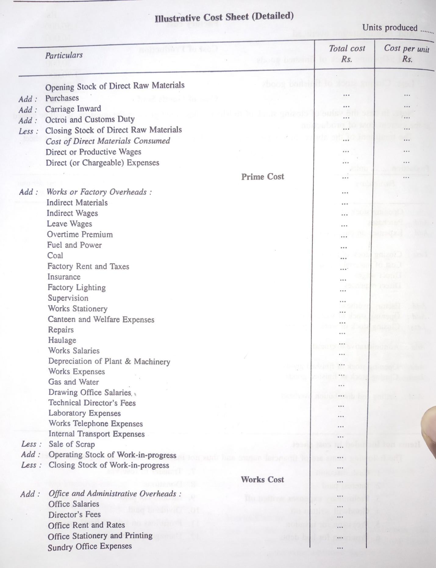

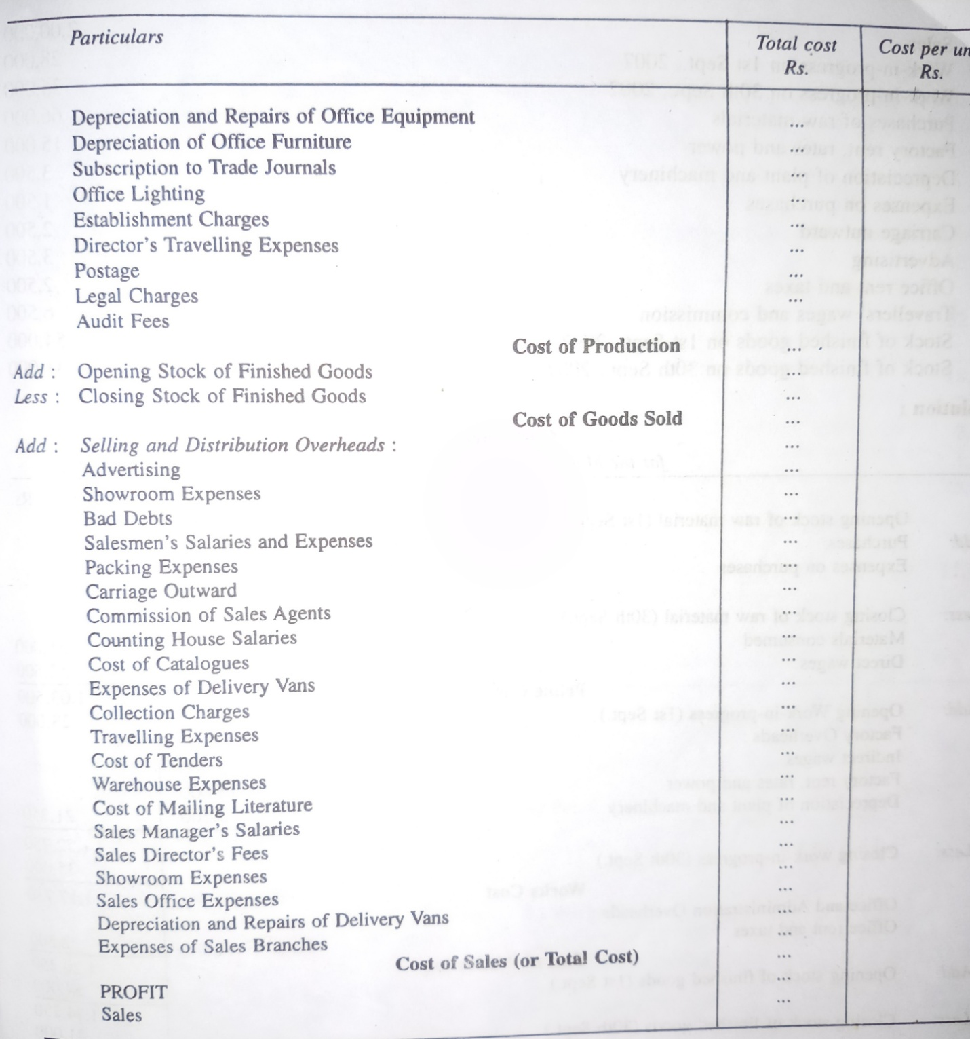
The following items are not included in cost sheet:

Interest paid donations
Preliminary expenses written off income tax paid
Good will written off dividend paid
Provision for taxation profit or loss on sale of fixed asset
Provision for bad debts damages payable at law

JOB COSTING
Job costing or job order costing is a method of cost ascertainment used in job order industries. Special features of such industries are as follows
- Production is against customer’s orders and not for stocks
- Each job has its own characteristics and requires special attention
- The flow of production from one department to another is not uniform.
Objectives of Job order costing:
- Cost of each job order is ascertained separately. This helps in finding out the profit or loss on each individual job.
- It enables management to detect those jobs which are more profitable and those which are unprofitable.
- It provides a basis for determining the cost of similar jobs undertaken in future.
- It helps management in controlling costs by comparing the actual costs with the estimated cost.
Job Costing Procedure:
- Job number
- Production order
- Job cost sheet
PROCESS COSTING
In many industries for manufacturing a product the raw material has to pass through several distinct stages of manufacturing in a pre-determined sequence. Each such a stage of manufacture is called as “Process”. The goods produced are identical and all factory processes are standardized. Method of cost ascertainment in such industries is known as “Process Costing” , in which costs are compiled for each process by prepare separate accounts of each process. In real world Process costing is used in the following industries..
- Textiles mills
- Sugar industries
- Chemical industries
- Oil refining
- Cement industries
- Paper industries
- Food processing
- Steel industries
- Paint industries
- Soap industries
- Bakery
Characteristics of Process Costing:
- The production is continuous and the final product is the result of sequence of processes
- Cost are accumulated by processes
- The products are standardized and homogeneous.
- The cost per unit produced is the average cost which is calculated by dividing the total process cost by the number of units
Comparison between Process Costing and Job Costing
Processing Costing | Job Costing
- Costs are compiled process-wise and cost per unit is the average cost i.e the total cost of the process divided by the number of units produced | - Costs are separately ascertained for each job, which is cost unit
- Production is of standardized products and cost units are identical. | - Production is of non-standard items with specification and instructions from the customers.
- Production is for stocks | - Production is against orders from customers
- Costs are computed at the end of a specific period. | - Costs are calculated when a job is completed
- The cost of one process is transferred to the next process in the sequence | - Cost of a job is not transferred to another job but to finished stock account.

Process costing Procedure:
- The factory is divided into a number of processes and an account is maintained for each process
- Each process account is debited with material cost, labor cost, direct cost, overheads allocated or apportioned to the process
- The output of a process is transferred to the next process in the sequence. In other words finished output of one process becomes input of the next process.
- The finished output of the last process is transferred to the finished goods account.
Process Losses and Wastages:
In industries which employ process testing a certain amount of loss occurs at various stages of production. Such a loss may arise due to chemical reaction, evaporation, efficiency etc., it is therefore necessary to keep accurate records of both input and output. Where loss occurs at a late stage in manufacture, it is apparent that financial loss is greater. This is because more and more costs are incurred in processes as products move towards completion stage. Process losses may be classified into a). Normal Loss b). Abnormal Loss
Normal Process Loss: That amount of loss which cannot be avoided because of the nature of material or process is normal processes. Any loss occur due to inherent characteristic of the product is Normal loss. Such loss is quite expected under normal conditions. Ex. Evaporation, sampling, unavoidable spoiled quantities etc., generally it not calculated while deriving stock.
Abnormal Process loss: this type of loss consists of loss due to carelessness machine break-down accident use of defective materials etc., this is arises due to abnormal factors and represents a loss which is over and above the normal loss.

COST-VOLUME-PROFIT ANALYSIS
Cost-volume-profit CVP analysis is an extension of the principles of marginal or variable costing. It follows directly from variable costing. This means that principles derived and applied in marginal costing are applicable here.
CVP analysis helps management in profit planning. CVP analysis studies the inter-relationship of three basic factors of business operations.
- Cost of Production
- Volume of Production/sales
- Profit.
These three factors are inter-connected in such away that they act and react on one another because of cause and effect relationship amongst them. The cost of a product determines its selling price and selling price determines the level of profit.
According to CIMA CVP analysis is the study of the effects on future profits of changes in fixed cost, variable cost, sales price, quantity and mix”.
An understanding of CVP analysis is extremely useful to management in budgeting and profit planning. It explains the impact of the following on the net profit.
- Changes in selling price
- Changes in volume of sales
- Changes in variable cost
- Changes in fixed cost.

BREAK-EVEN ANALYSIS
Break even analysis is a widely used technique to study the CVP relationship. Break even means the volume of production or sales where there is no profit or loss. Breakeven point is the volume of production or sales where total cost are equal to revenue. It helps in finding out the relationship of costs and revenues to output. In understanding the breakeven cost volume and profit are always are used.
BEP in narrow meaning: in this break even analysis is concerned with determining breakeven point. Breakeven point is that level of production and sales where there is no profit and no loss. At this point total cost is equal to total sales revenue
BEP in broad meaning: it is used to determine probable profit or loss at any given level of production or sales. It also helps to determine the amount or volume of sales to earn a desired amount of profit.
Assumptions of Break-even Analysis:
- All costs can be separated into fixed and variable components
- The variable cost per unit remains constant and total variable cost varies in direct proportion to the volume of production.
- Total fixed cost remain constant
- Selling price per unit does not change as volume changes
- There is only one product or in the case of multiple products, the sales mix does not change
- There is synchronization between production and sales.
- Productivity per worker does not change.
- There will be no change in the general price level.

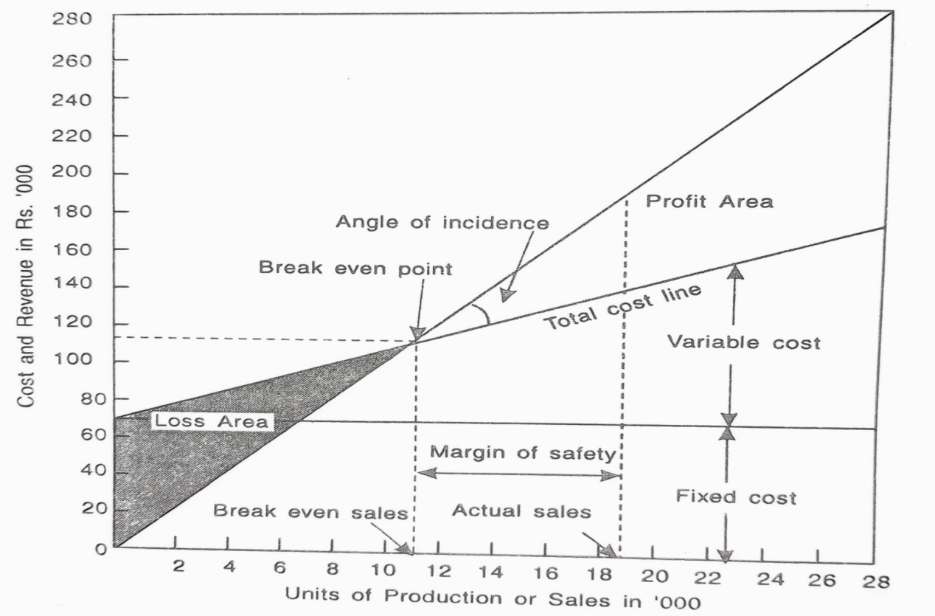

Formulas:
Contribution = sales – variable cost
Contribution = fixed cost + Profit
Contribution = fixed cost – loss
Profit volume ratio or P/V ratio: contribution/sales or c-s/s
Or change in contribution / change in sales
Or change in profit / change in sales
Breakeven Point (in Units) = Total fixed cost/Contribution per unit = F/S-V
BEP (in rupees) = total fixed cost/contribution x sales

